WEB DESIGN PROJECT draft content Pt2

About page

Introduction

Who we are..

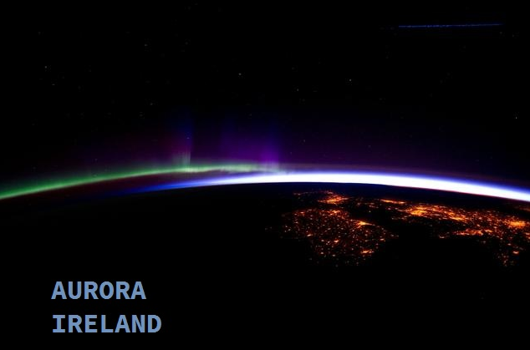

The Aurora Ireland project resulted from a group of like-minded people coming together, all of whom possess the strong belief that there CAN and SHOULD be an Irish presence in outer space.  
  
The key inspiration came from one of Ireland’s most famous business leaders, Charles M. Byrne.  
Mikey, as he is more popularly known, is the head of the country’s biggest utility provider ByrnePower and was willing to put his own personal wealth into play to realise his dream, and the dream of many others, to launch Ireland’s very own space travel company.  
  
From those beginnings, Aurora Ireland connected with the Brazilian Space Agency AEB who were revamping their own space program so it presented an excellent opportunity to partner up. AEB are facilitating the launch site & possess a great deal of expertise in space technology.  
  
Today, Aurora Ireland has two years of research, design and testing completed and we are well advanced in hitting our key milestones to enable space travellers to make that journey with an Irish company.

Partners



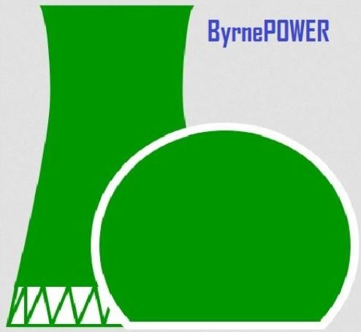

Careers

Join us on this journey..

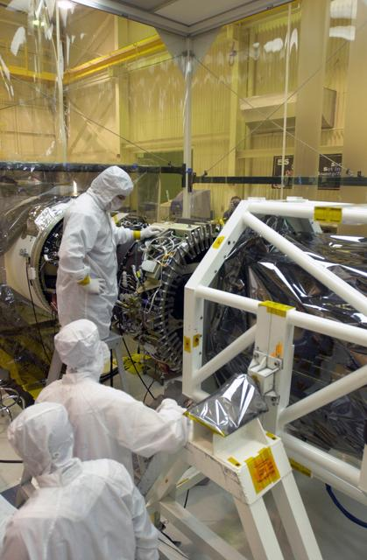

Aurora Ireland can truly help you to take your career to a higher level.

We have many exciting openings across the career range from business-oriented to highly technical.   
Includes Aeronautics Engineers, Operations Technicians, Code Developers, Sales & Marketing Professionals and many more.. yes we even need some Rocket Scientists!  
  
If you think this flightpath is for you, please get in touch <here> (link to contact form)